
HIGHER SCHOOL CERTIFICATE
TRIAL EXAMINATION
2017

Economics

Total marks – 100

Pages 2–12
Section I

General Instructions
- Reading time – 5 minutes
- Working time – 3 hours
- Write using black pen

20 marks
- Attempt Questions 1–20
- Allow about 35 minutes for this section

Pages 10–20
Section II

40 marks
- Attempt Questions 21–24
- Allow about 1 hour and 15 minutes for this section

- Board-approved calculators may
Section III

be used
Pages 13–24

20 marks
  - Attempt either Question 25 or Question 26
  - Allow about 35 minutes for this section

Page 25-28
Section IV

20 marks
    - Attempt either Question 27 or Question 28
    - Allow about 35 minutes for this section

2030

Section I

20 marks
Attempt Questions 1–20
Allow about 35 minutes for this section

Use the multiple-choice answer sheet for Questions 1–20.

- A country is experiencing an external stability crisis.
Which of the following organisations would most likely provide assistance?

  - G20
  - United Nations
  - World Trade Organisation
  - International Monetary Fund

- The graph below shows the introduction of a quota on imported tomatoes with a world price of $3.00 per kilogram.
S
D
Price
($)

4

3

0
4 6 8 10 12
Quantity (kg)

Which of the following is the most likely impact of the introduction of the quota?

  - A decrease in sales for domestic tomato producers
  - An increase in tomatoes sold in the domestic economy
  - A decrease in sales of imported tomatoes to 4 kilograms
  - An increase in sales of imported tomatoes to 12 kilograms

- 2 -
- The graph below shows the introduction of a subsidy on the production of solar panels.

Price
($)
S
D
S1

6
5
4

0
6 8 10
Quantity (thousands)

Which of the following is the cost to the government of the subsidy?

  - $4,000
  - $8,000
  - $12,000
  - $20,000

- Which of the following is an argument in favour of increasing a quota?

  - Prevention of dumping
  - Protecting an infant industry
  - Increasing efficiency in an industry
  - Protecting domestic employment

- A hypothetical economy reduces tariffs on imported goods.
Other things being equal, which of the following is the most likely impact on imports and national income in that economy?

(A)  (B)  (C)  (D) | Imports | National income
(A)  (B)  (C)  (D) | Increase | Decrease
(A)  (B)  (C)  (D) | Increase | Increase
(A)  (B)  (C)  (D) | Decrease | Increase
(A)  (B)  (C)  (D) | Decrease | Decrease

– 3 –
- The table below shows data for a hypothetical economy with a flexible exchange rate.

Components of the Balance of Payments | $ Billions
Net Primary Income | -50
Capital Account | -30
Financial Account | 150
Balance on Goods and Services | 100
Net Secondary Income | ?

Using the data above, what is the value of net secondary income?

  - -$120 billion
  - -$170 billion
  - $120 billion
  - $170 billion

- Other other things being equal, which of the following is most likely to shift the supply curve for the Australian dollar from SS to S1S1?

Price
($USD)
S
S1
D

//
/
///
//

S
S1
/
///
0
Quantity

  - An increase in foreign tourists to Australia
  - An increase in purchases of imports by Australians
  - A decrease in foreign investment by Australians
  - A decrease in direct investment by foreigners in Australia

– 4 –

- A government is looking to implement policy to address short-term aggregate demand issues.
Which of the following would have the shortest impact time lag to achieve that policy?

  - Fiscal policy
  - Monetary policy
  - Environment policy
  - Micro-economic reform

- The central bank of a hypothetical economy fixes their exchange rate below the market equilibrium price.
Which of the following describes the action taken by the central bank?

  - Sale of domestic currency
  - Increase domestic money supply
  - Increase in domestic interest rates
  - Sale of international currency reserves

- A firm is experiencing increased prices for imported production inputs as a result of a depreciation of the domestic currency.
Which of the following best describes the cause of inflation in the domestic economy?

  - Headline inflation
  - Underlying inflation
  - Demand inflation
  - Cost inflation

– 5 –
- The table below shows selected data for a hypothetical economy.

Year | Income  ($ million) | Consumption  ($ million)
1 | 1 500 | 500
2 | 2 000 | 600
3 | 2 500 | 700

Other things being equal, by how much must the government increase spending to increase national income in Year 4 to $3 000 million?

  - $100 million
  - $200 million
  - $300 million
  - $400 million

- Which of the following is a domestic reason that economic development varies between economies?

  - Factor endowments
  - Reductions in foreign aid
  - International financial architecture
  - The activities of the World Trade Organisation

- The table below shows selected data for a hypothetical economy.

Year | Nominal GDP  ($ billion) | Consumer Price Index
1 | 600 | 100
2 | 650 | 110
3 | 750 | 121

Which of the following is the rate of growth in real GDP for Year 3?

  - -4.6%
  - 4.9%
  - 11%
  - 15%

– 6 –
- The table below shows selected data for a hypothetical economy.

Year | Working age population  (thousands) | Employed persons  (thousands) | Unemployed persons  (thousands) | Hidden Unemployed  (thousands)
1 | 12 500 | 9 500 | 1 500 | 800
2 | 16 000 | 13 900 | 1 100 | 1 000

Which of the following best describes the changes from Year 1 to Year 2 in the labour force participation rate and the unemployment rate for this economy?

(A)  (B)  (C)  (D) | Labour Force Participation Rate | Unemployment Rate
(A)  (B)  (C)  (D) | Increased | Decreased
(A)  (B)  (C)  (D) | Increased | Increased
(A)  (B)  (C)  (D) | Decreased | Increased
(A)  (B)  (C)  (D) | Decreased | Decreased

- Other things being equal, what is the most likely impact of an increase in official United States interest rates on the value of the Australian dollar?

  - Depreciates as a result of increased demand for Australian exports
  - Appreciates as a result of increased demand for Australian exports
  - Depreciates as investors seek higher returns in the United States
  - Appreciates as investors seek higher returns in Australia

- In a hypothetical economy, the level of national savings increases.
Other things being equal, what is the most likely effect of that increase on Net Foreign Debt and Net Primary Income in that economy?

(A)  (B)  (C)  (D) | Net Foreign Debt | Net Primary Income
(A)  (B)  (C)  (D) | Increases | Decreases
(A)  (B)  (C)  (D) | Increases | Increases
(A)  (B)  (C)  (D) | Decreases | Increases
(A)  (B)  (C)  (D) | Decreases | Decreases

– 7 –
- The table below shows selected data for a hypothetical economy.

Year | Real GDP  ($ billions) | Consumer Price Index | Unemployment Rate  (%)
1 | 3 500 | 30 | 5.0
2 | 3 700 | 31 | 6.2

Which policy response is most appropriate for policy makers in Year 3 focused only on achieving an inflation outcome of 2%?

(A)  (B)  (C)  (D) | Fiscal Policy | Monetary Policy
(A)  (B)  (C)  (D) | Expansionary | Expansionary
(A)  (B)  (C)  (D) | Contractionary | Expansionary
(A)  (B)  (C)  (D) | Expansionary | Contractionary
(A)  (B)  (C)  (D) | Contractionary | Contractionary

- The table below shows selected hypothetical data for the Australian economy.

Year | Terms of Trade | Trade Weighted index
1 | 100 | 50
2 | 98 | 52

Other things being equal, which of the following best describes the changes in the economy between Year 1 and Year 2?

(A)  (B)  (C)  (D) | Export Price Index | Import Price Index
(A)  (B)  (C)  (D) | Increase | Decrease
(A)  (B)  (C)  (D) | Increase | Increase
(A)  (B)  (C)  (D) | Decrease | Increase
(A)  (B)  (C)  (D) | Decrease | Decrease

– 8 –

- The Reserve Bank of Australia buys Commonwealth Government securities from the banks.
Other things being equal, what is the most likely impact of this purchase on the supply of cash in the short term money market and the unemployment rate?

(A)  (B)  (C)  (D) | Supply of cash in short term money market | Unemployment rate
(A)  (B)  (C)  (D) | Decrease | Decrease
(A)  (B)  (C)  (D) | Increase | Decrease
(A)  (B)  (C)  (D) | Decrease | Increase
(A)  (B)  (C)  (D) | Increase | Increase

- A hypothetical economy introduces laws prohibiting conduct that reduces competition.
Which of the following best describes the most likely economic impact of this law?

  - Aggregate demand shifts to the left, reducing the general price level and output
  - Aggregate demand shifts to the right increasing the general price level and output
  - Aggregate supply shifts to the left, increasing the general price level and reducing output
  - Aggregate supply shifts to the right, reducing the general price level and increasing output.

– 9 –

BLANK PAGE

– 10 –

BLANK PAGE

– 11 –

BLANK PAGE

– 12 –

2017 HIGHER SCHOOL CERTIFICATE
TRIAL EXAMINATION

Economics

Section II

40 marks
Attempt Questions 21–24
Allow about 1 hour and 15 minutes for this section

Answer the questions in the spaces provided. These spaces provide guidance for the expected length of response.

Extra writing space is provided on pages 18 and 19. If you use this space, clearly indicate which question you are answering.
Do NOT write in this area.

Write your Student Number at the top of this page.

Please turn over

Student Number

– 13 –
Office Use Only – Do NOT write anything, or make any marks below this line.

2031 15110
6741310293

Question 21 (10 marks)

(a) | Distinguish between the headline and underlying inflation rates. | 2
 | ...............................................................................................................................
 | ...............................................................................................................................
 | ...............................................................................................................................
 | ...............................................................................................................................
 | ...............................................................................................................................
(b) | Explain why Australia’s unemployment rate may not be a true indication of the level of utilisation in the Australian labour market. | 4
 | ...............................................................................................................................
 | ...............................................................................................................................
 | ...............................................................................................................................
 | ...............................................................................................................................
 | ...............................................................................................................................
 | ...............................................................................................................................
 | ...............................................................................................................................
 | ...............................................................................................................................
 | ...............................................................................................................................

Question 21 continues on page 15
Do NOT write in this area.

– 14 –
Office Use Only – Do NOT write anything, or make any marks below this line.
0730310295

Question 21 (continued)
(c) | Explain how government policies can be used to reduce the non-accelerating inflation rate of unemployment (NAIRU). | 4
...............................................................................................................................
...............................................................................................................................
...............................................................................................................................
...............................................................................................................................
...............................................................................................................................
...............................................................................................................................
...............................................................................................................................
...............................................................................................................................
...............................................................................................................................
Do NOT write in this area.
...............................................................................................................................
...............................................................................................................................
...............................................................................................................................
...............................................................................................................................

End of Question 21

– 15 –
Office Use Only – Do NOT write anything, or make any marks below this line.
8668310293
Do NOT write in this area.

Question 22 (10 marks)

(a) | Describe ONE bilateral free trade agreement and ONE multilateral free trade agreement which Australia has signed. | 4
 | ...............................................................................................................................
 | ...............................................................................................................................
 | ...............................................................................................................................
 | ...............................................................................................................................
 | ...............................................................................................................................
 | ...............................................................................................................................
 | ...............................................................................................................................
 | ...............................................................................................................................
 | ...............................................................................................................................
 | ...............................................................................................................................
 | ...............................................................................................................................
 | ...............................................................................................................................

Question 22 continues on page 17

– 16 –
Office Use Only – Do NOT write anything, or make any marks below this line.
5654310295

Question 22 (continued)

(b) | Assess the effectiveness of the World Trade Organisation. | 6
...............................................................................................................................
...............................................................................................................................
...............................................................................................................................
...............................................................................................................................
...............................................................................................................................
...............................................................................................................................
...............................................................................................................................
...............................................................................................................................
...............................................................................................................................
Do NOT write in this area.
...............................................................................................................................
...............................................................................................................................
...............................................................................................................................
...............................................................................................................................
...............................................................................................................................
...............................................................................................................................
...............................................................................................................................
...............................................................................................................................
...............................................................................................................................
...............................................................................................................................

End of Question 22

– 17 –
Office Use Only – Do NOT write anything, or make any marks below this line.
8839310293

Question 23 (10 marks)

(a) | The diagram below represents tariff levels on oranges in an economy with a world price of $2 per kilogram. | 2

Price
S

$3

$2
D

100 200 300 400 Quantity (kg)

Explain what would happen to domestic supply and imports if the tariff were to change to $0.50.

...............................................................................................................................
...............................................................................................................................
...............................................................................................................................
...............................................................................................................................
...............................................................................................................................
...............................................................................................................................

(b) | Outline TWO reasons for protection. | 2
...............................................................................................................................
...............................................................................................................................
...............................................................................................................................
...............................................................................................................................
...............................................................................................................................
...............................................................................................................................

Question 23 continues on page 19

– 18 –
Office Use Only – Do NOT write anything, or make any marks below this line.
2984310298

Question 23 (continued)

(c) | Discuss the impact on the Australian economy of a reduction in the level of domestic protection. | 6

...............................................................................................................................
...............................................................................................................................
...............................................................................................................................
...............................................................................................................................
...............................................................................................................................
...............................................................................................................................
...............................................................................................................................
...............................................................................................................................
...............................................................................................................................
Do NOT write in this area.
...............................................................................................................................
...............................................................................................................................
...............................................................................................................................
...............................................................................................................................
...............................................................................................................................
...............................................................................................................................
...............................................................................................................................
...............................................................................................................................
...............................................................................................................................
...............................................................................................................................
...............................................................................................................................

End of Question 23

– 19 –
Office Use Only – Do NOT write anything, or make any marks below this line.
1918310294

Question 24 (10 marks)

(a) | Distinguish between an award and a common law employment contract. | 2
...............................................................................................................................
...............................................................................................................................
...............................................................................................................................
...............................................................................................................................

(b) | Explain how decentralised wage determination increases efficiency in an economy.  ...............................................................................................................................  ...............................................................................................................................  ...............................................................................................................................  ...............................................................................................................................  ...............................................................................................................................  ...............................................................................................................................  ...............................................................................................................................  ...............................................................................................................................  ...............................................................................................................................  ...............................................................................................................................  ...............................................................................................................................  ............................................................................................................................... | 4

Question 24 continues on page 21
Do NOT write in this area.

– 20 –
Office Use Only – Do NOT write anything, or make any marks below this line.
7407310293

Question 24 (continued)

(c) | Explain how deregulation can increase economic growth. | 4
...............................................................................................................................
...............................................................................................................................
...............................................................................................................................
...............................................................................................................................
...............................................................................................................................
...............................................................................................................................
...............................................................................................................................
...............................................................................................................................
...............................................................................................................................
Do NOT write in this area.
...............................................................................................................................
...............................................................................................................................
...............................................................................................................................
...............................................................................................................................

End of Question 24

– 21 –
Office Use Only – Do NOT write anything, or make any marks below this line.
4957310290

Section II extra writing space

If you use this space, clearly indicate which question you are answering.

– 22 –
Do NOT write in this area.
Office Use Only – Do NOT write anything, or make any marks below this line.

4792310297

Section II extra writing space

If you use this space, clearly indicate which question you are answering.

– 23 –
Do NOT write in this area.
Office Use Only – Do NOT write anything, or make any marks below this line.

5461310291

BLANK PAGE

– 24 –

Office Use Only – Do NOT write anything, or make any marks below this line.
Do NOT write in this area.

9410310299

2017 HIGHER SCHOOL CERTIFICATE TRIAL EXAMINATION

Economics

Section III

20 marks
Attempt either Question 25 or Question 26 Allow about 35 minutes for this section

Answer the question in the Sections III and IV Writing Booklet. Extra writing booklets are available.

Your answer will be assessed on how well you:
- demonstrate knowledge and understanding relevant to the question
- use the information provided
- apply relevant economic terms, concepts, relationships and theory
- present a sustained, logical and cohesive response

Question 25 (20 marks)

Please turn over

2032
– 25 –

Question 25 (20 marks)

Analyse the impact of Australia’s fiscal policy on internal and external stability. In your response, refer to the economic information provided.

Macro management is also called "demand management" and "stabilisation policy". These days, the management is done primarily by the Reserve Bank, using its "monetary policy" (manipulation of interest rates), though both the present and previous governor have often publicly wished they were getting more help from "fiscal policy" (the budget).

Ross Gittins, SMH
August 6. 2017

Australia GDP Growth
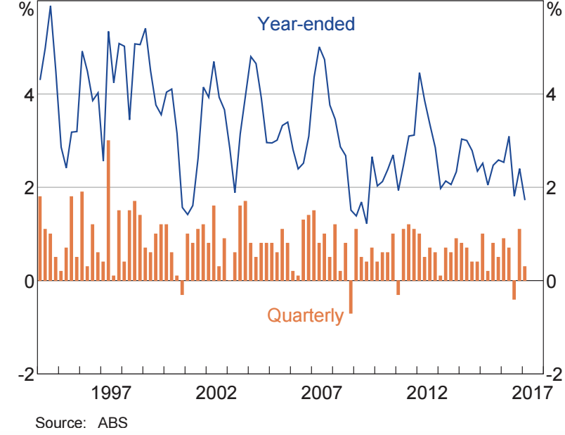
Source: ABS

OR

– 26 –
Question 26 (20 marks)

Analyse the impact of trends in Australia’s balance of payments on the Australian economy. In your response, refer to the economic information provided.

But recently the currency has received support from a synchronised global economic expansion, a well-performing Australian economy, a structural narrowing in Australia’s current account deficit and broad-based US dollar weakness.
Australia’s current account deficit has shrunk to $A3.1 billion in the quarter ended March 31 – the lowest in 15 years.

Narayanan Somasundaram
Economist, ANZ Bank

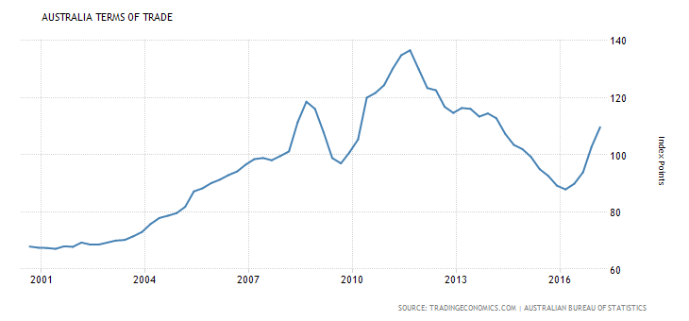

Please turn over

– 27 –

Section IV

20 marks
Attempt either Question 27 or Question 28 Allow about 35 minutes for this section

Answer the question in the Sections III and IV Writing Booklet. Extra writing booklets are available.

Your answer will be assessed on how well you:
- demonstrate knowledge and understanding relevant to the question
- apply relevant economic information, terms, concepts, relationships and theory
- present a sustained, logical and cohesive response

Question 27 (20 marks)

For an economy other than Australia, assess the effectiveness of policies to achieve economic growth and economic development.

OR

Question 28 (20 marks)

Assess the effectiveness of Australia’s policies to achieve environmental sustainability.

End of paper

– 28 –

