Student number ……………………………………..

Higher School Certificate

2018

Trial Examination

Economics

General Instructions  - Reading time – 5 minutes  - Working time – 3 hours  - Board approved calculators may be used  - Write using black or blue pen (black pen is preferred) | Section I  Total marks (20)  Attempt questions 1-20  Allow about 35 minutes for this section  Section II  Total marks (40)  Attempt questions 21-24  Allow about 1 hour 15 minutes for this section  Section III  Total marks (20)  Attempt EITHER Question 25 or 26  Allow about 35 minutes for this section  Section IV  Total marks (20)  Attempt EITHER Question 27 or 28  Allow about 35 minutes for this section  Total /100

SECTION I
Total marks (20)
Attempt Questions 1 –20
Allow about 35 minutes for this section

Answer the questions on the multiple choice answer sheet provided

- Which of the following is the likely effect of higher interest rates in Australia relative to overseas interest rates?

- An increase in supply of Australian dollars and an increase in capital inflow
- An increase in supply of Australian dollars and an decrease in capital outflow
- An increase in demand for Australian dollars and an increase in capital inflow
- An increase in demand for Australian dollars and an increase in capital outflow

Refer to the graph below to answer Question 2
$US/$AUD
Quantity
Q₁
Q₂
Q
83c
80c
S of $AUD
D of $AUD
0

- Under a managed exchange rate system, what action would the Reserve Bank of Australia take to keep the $AUD at 83c?

- It would buy the equivalent of Q₂ – Q₁ Australian dollars
- It would sell the equivalent of Q₂ – Q₁ Australian dollars
- It would buy the equivalent of Q₂ – Q Australian dollars
- It would sell the equivalent of Q₂ – Q Australian dollars

The diagram below shows the demand and supply curve of a firm. Refer to this diagram to answer Question 3.

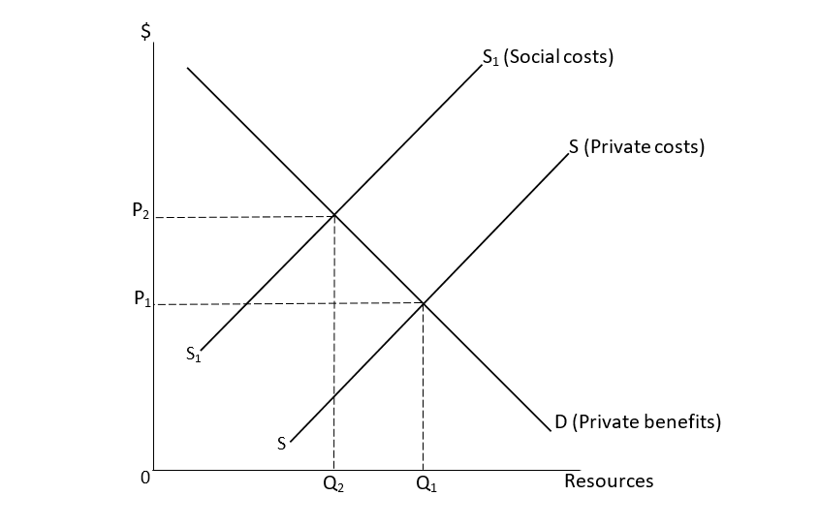

- What implications are there to the environment, consumers and producers when the supply curve moves from SS to S₁S₁?

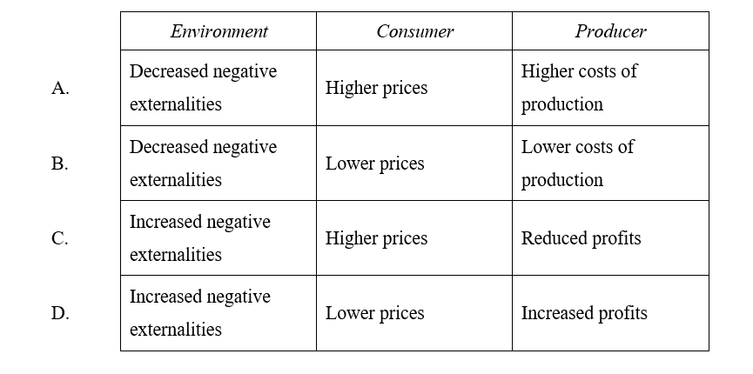

Use the information below to answer Question 4.

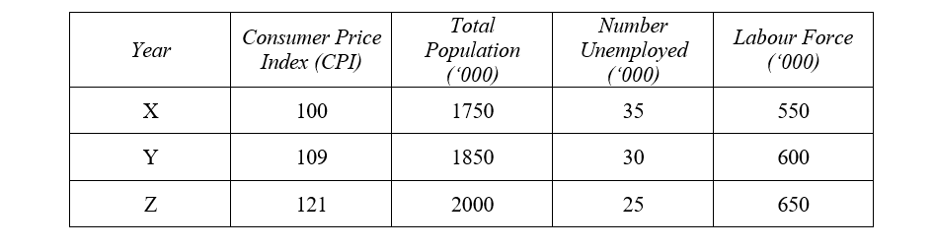

- From Year Y to Year Z, which statement is correct for this economy?

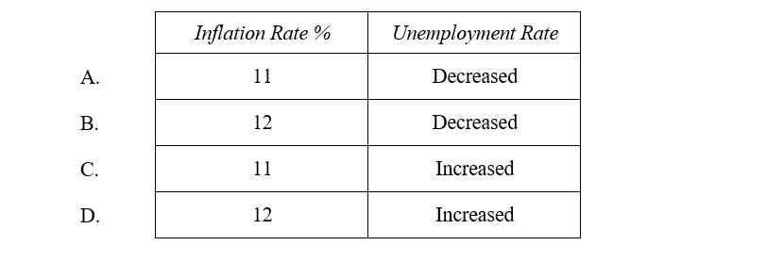

- What are the impacts of a reduction in protection on the Australian economy?

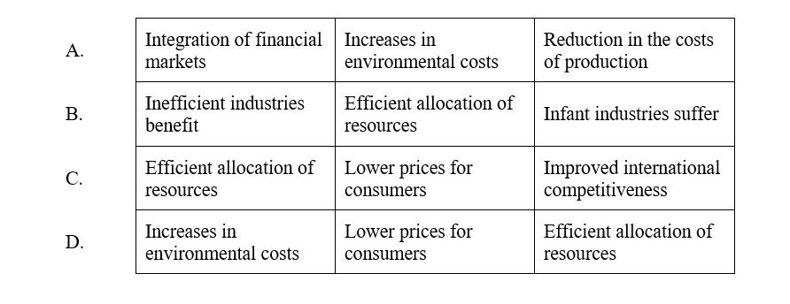

- The Federal Government is planning a budget deficit for a particular year. In which way could this deficit be financed?

- By increasing tariff levels
- By reducing interest rates
- By using domestic savings
- By implementing structural change

- Which combination of actions by the Reserve Bank of Australia is most likely to cause a decrease in the value of the Australian dollar?

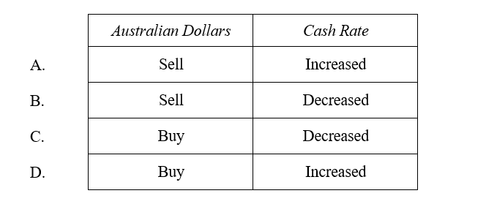

The table below shows selected data for a hypothetical economy and relates to Question 8.

Year | Nominal GDP $B | CPI
1 | 750 | 100
2 | 800 | 108
3 | 935 | 117

- What is the Inflation rate and Real GDP in year 3?

Inflation Real GDP $B

A
8.3 %. | 799
17%. | 750
17% | 776
8.3 %. | 863
B
C
D

The following table shows Balance of Payments data for an economy with a floating exchange rate. Use the information below to answer Question 9.

Balance of Payments Item | $ Billions
Balance of Goods and Services | -16
Net Primary Income | -56
Net Secondary Income | 4
Capital Account | 2
Financial Account | ?

- What is the value of the Financial Account for this economy?

- -$56 billion
- -$70 billion
- $36 billion
- $66 billion

- Which of the following statements best describes the implementation and impact of economic policies?

- Macroeconomic policy is quickly implemented through the annual budget.
- Macroeconomic policy shifts the aggregate supply curve to improve productivity.
- Monetary policy is quicker to implement than fiscal policy but takes longer to affect economic activity.
- Monetary policy is slower to implement than fiscal policy and is quicker to affect economic activity.

11 The following table shows data for income and consumption in a closed economy.

Disposable income $m | Consumption  $m
50 | 50
100 | 80
150 | 110
200 | 140
250 | 170

What is the value of the marginal propensity to consume (MPC) and the simple multiplier?

- The MPC is 0.4 and the multiplier is 2.5.
- The MPC is 0.8 and the multiplier is 5.
- The MPC is 0.6 and the multiplier is 2.5.
- The MPC is 0.9 and the multiplier is 10.

12 The table shows data for a hypothetical economy.

Year | Employed Persons | Total Labour Force | Gini  co-efficient
1 | 11 750 000 | 12 500 000 | 0.315
2 | 11 800 000 | 12 700 000 | 0.335

What is the effect of the changes from Year 1 to Year 2 on the unemployment rate and income inequality?

 | Unemployment rate | Income inequality
(A) | Increased | Decreased
(B) | Increased | Increased
(C) | Decreased | Decreased
(D) | Decreased | Increased

13 An emerging country is experiencing balance of payment difficulties and instability in its exchange rate.

Which of the following international organisations could provide the country with financial assistance?

- The World Trade Organisation
- The World Bank
- The International Monetary Fund
- The Organisation for Economic Co-operation and Development

14 A government wants to protect its industries from import competition.

Which combination of trade policies would be most appropriate to achieve this?

 | Tariffs on imported goods | Quotas on imported goods
(A) | Increase | Increase
(B) | Increase | Decrease
(C) | Decrease | Decrease
(D) | Decrease | Increase

15 How would profits earned by Australian enterprises operating overseas be recorded in Australia’s balance of payments?

(A) As a debit on the financial account
(B) As a credit on the financial account
(C) As a credit item on Net primary income in the current account
(D) As a debit item on Net primary income in the current account

16 Which of the following combinations is most likely to reduce Australia’s volume of exports?

 | Australian dollar | Global economy
(A) | Appreciation | Slowing growth rate
(B) | Depreciation | Slowing growth rate
(C) | Appreciation | Increasing growth rate
(D) | Depreciation | Increasing growth rate

17 The government decides to reduce the subsidy provided to car manufacturers in Australia.

Which of the following is a likely short–term consequence of this action?

- Australian car manufacturers would improve their international competitiveness.
(B) Input costs for Australian car manufacturers are reduced making cars less expensive.
(C) There will be a redistribution of income away from the government towards local
producers.
(D) The Australian car manufacturing industry is likely to restructure causing an increase in unemployment.

18 What changes will occur to automatic stabilisers during a sustained decrease in the level of economic activity?

- Welfare payments will increase and taxation revenue will decrease.
- Welfare payments will decrease and taxation revenue will decrease.
- Welfare payments will decrease and taxation revenue will increase.
- Welfare payments will increase and taxation revenue will increase.

19 Which of the following factors can restrict economic growth and development in developing economies?

- High population growth rates, low per capita incomes and low levels of capital
accumulation
(B) Low population growth rates, high levels of foreign debt and high levels of capital
accumulation
(C) High levels of domestic savings, low levels of technology and high levels of
foreign direct investment
(D) Low levels of domestic savings, low per capita incomes and high levels of exports

20 Which of the following policy options may reduce the Non Accelerating Inflation Rate of
Unemployment (NAIRU)?
(A) Reduce the retirement age
(B) Encouraging those who receive unemployment benefits to re-enter the workforce
(C) Decreased interest rates
(D) Decreasing government expenditure on TAFE

End of SECTION 1

SECTION II
Total marks (40)
Attempt Questions 21 – 24
Allow about 1 hour and 15 minutes for this section
Answer the questions in the spaces provided.
These spaces provide guidance for the expected length of response.

Question 21 (10 marks)

Use the following information to answer parts (a).

 | (millions)
Population over 15 | 36
Full time workers | 21
Part time workers | 4
Unemployed workers | 2
Students | 1

- Calculate the following: 2

Participation rate: ……………………………………………………………………….
…………………………………………………………………………………………..
Unemployment rate: ……………………………………………………………………
…………………………………………………………………………………………..

- Explain what the consequences are when the unemployment rate drops below the 2
non-accelerating inflation rate of unemployment.
…………………………………………………………………………………………..
…………………………………………………………………………………………..
…………………………………………………………………………………………..
…………………………………………………………………………………………..
…………………………………………………………………………………………..
…………………………………………………………………………………………..
Question 21 continues on page 12
- What are TWO main problems associated with the calculation of the official 2
unemployment rate?
…………………………………………………………………………………………..
…………………………………………………………………………………………..
…………………………………………………………………………………………..
…………………………………………………………………………………………..
…………………………………………………………………………………………..
…………………………………………………………………………………………..
- Evaluate the impacts of an increased participation rate on the Australian economy. 4
…………………………………………………………………………………………..
…………………………………………………………………………………………..
…………………………………………………………………………………………..
…………………………………………………………………………………………..
…………………………………………………………………………………………..
…………………………………………………………………………………………..
…………………………………………………………………………………………..
…………………………………………………………………………………………..
…………………………………………………………………………………………..
…………………………………………………………………………………………..
…………………………………………………………………………………………..
…………………………………………………………………………………………..
…………………………………………………………………………………………..
…………………………………………………………………………………………..
…………………………………………………………………………………………..
End of Question 21

Question 22 (10 marks)

A hypothetical economy has a simple multiplier of 2.5.

- Calculate the change in national income that would result from an increase in 1
investment of $200 million.
…………………………………………………………………………………………..
…………………………………………………………………………………………..
…………………………………………………………………………………………..
- Outline how economic growth in a major trading partner might influence economic 2
growth in Australia.
…………………………………………………………………………………………..
…………………………………………………………………………………………..
…………………………………………………………………………………………..
…………………………………………………………………………………………..
…………………………………………………………………………………………..
…………………………………………………………………………………………..
- Explain how an increase in Australia’s marginal propensity to save (MPS) affects 3
Australia’s economic growth?
…………………………………………………………………………………………..
…………………………………………………………………………………………..
…………………………………………………………………………………………..
…………………………………………………………………………………………..
…………………………………………………………………………………………..
…………………………………………………………………………………………..
…………………………………………………………………………………………..
…………………………………………………………………………………………..
…………………………………………………………………………………………..
Question 22 continues on page 14

Question 22 (continued)

- Explain the effects of an increased rate of economic growth on the Australian
Government budget. 4
…………………………………………………………………………………………..
…………………………………………………………………………………………..
…………………………………………………………………………………………..
…………………………………………………………………………………………..
…………………………………………………………………………………………..
…………………………………………………………………………………………..
…………………………………………………………………………………………..
…………………………………………………………………………………………..
…………………………………………………………………………………………..
…………………………………………………………………………………………..
…………………………………………………………………………………………..
…………………………………………………………………………………………..
…………………………………………………………………………………………..
…………………………………………………………………………………………..
…………………………………………………………………………………………..
…………………………………………………………………………………………..
…………………………………………………………………………………………..
…………………………………………………………………………………………..
…………………………………………………………………………………………..
…………………………………………………………………………………………..
…………………………………………………………………………………………..
End of Question 22
Question 23 (10 marks)

- Define the term ecologically sustainable development. 1
…………………………………………………………………………………………..
…………………………………………………………………………………………..
…………………………………………………………………………………………..
- Distinguish between private goods and public goods. 2
…………………………………………………………………………………………..
…………………………………………………………………………………………..
…………………………………………………………………………………………..
…………………………………………………………………………………………..
- Discuss TWO causes of market failure that can arise in the allocation of 3
environmental resources.
…………………………………………………………………………………………..
…………………………………………………………………………………………..
…………………………………………………………………………………………..
…………………………………………………………………………………………..
…………………………………………………………………………………………..
…………………………………………………………………………………………..
…………………………………………………………………………………………..
…………………………………………………………………………………………..
…………………………………………………………………………………………..
…………………………………………………………………………………………..
…………………………………………………………………………………………..
…………………………………………………………………………………………..

Question 23 continues on page 16
- Assess TWO government policies aimed at improving ecologically sustainable 4
development in Australia.

…………………………………………………………………………………………..
…………………………………………………………………………………………..
…………………………………………………………………………………………..
…………………………………………………………………………………………..
…………………………………………………………………………………………..
…………………………………………………………………………………………..
…………………………………………………………………………………………..
…………………………………………………………………………………………..
…………………………………………………………………………………………..
…………………………………………………………………………………………..
…………………………………………………………………………………………..
…………………………………………………………………………………………..
…………………………………………………………………………………………..
…………………………………………………………………………………………..
…………………………………………………………………………………………..
…………………………………………………………………………………………..
…………………………………………………………………………………………..
…………………………………………………………………………………………..
…………………………………………………………………………………………..
…………………………………………………………………………………………..
…………………………………………………………………………………………..
…………………………………………………………………………………………..
End of Question 23

Question 24 (10 marks)

(a) Define the term globalisation. 1

(b) How has globalisation contributed to changes in the international business cycle? 2

(c) Describe TWO economic consequences of an unequal distribution of global income and
wealth. 2

Question 24 continues on page 18

Question 24 (continued) Marks

(d) Discuss the factors that cause global inequalities. 5

End of SECTION II

SECTION III
Total marks (20)
Attempt Question 25 or Question 26
Allow about 35 minutes for this section.

In your answer you will be assessed on how well you:
■ demonstrate knowledge and understanding relevant to the question
■ use the information provided
■ apply relevant economic terms, concepts, relationships and theory
■ present a sustained, logical and cohesive response

Question 25 (20 marks)

Explain the role that the Australian government’s macroeconomic policies play in achieving sustainable economic growth and price stability. In your response, you should refer to the economic information provided.

At its meeting today, the Board decided to leave the cash rate unchanged at 1.50 per cent. The recent data on the Australian economy have been consistent with the Bank's central forecast for GDP growth to pick up, to average a bit above 3 per cent in 2018 and 2019. Business conditions are positive and non-mining business investment is increasing. Higher levels of public infrastructure investment are also supporting the economy. Stronger growth in exports is expected. One continuing source of uncertainty is the outlook for household consumption. Household income has been growing slowly and debt levels are high.

Source: Statement by Phillip Lowe, Governor, Reserve Bank of Australia,
Monetary Policy Decision
5 June 2018

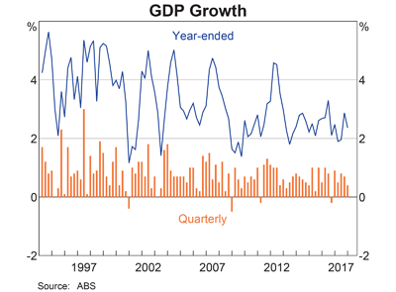

OR

Question 26 (20 marks)

Explain how the Australian government uses macroeconomic policies to achieve its economic objectives. In your response, you should refer to the economic information provided.

The Government is sticking to its plan for building a stronger economy for Australia. Through disciplined fiscal management and improved receipts from stronger economic growth, the budget position is improving. The Government is continuing to back Australian businesses to invest and create more jobs, remain internationally competitive and encourage innovative thinking for the future. The economic potential in regional Australia is continuing to be unlocked. The Government is backing our farmers and securing the future of one of our international icons and great natural wonders — the Great Barrier Reef.

Source: 2018/19 Budget

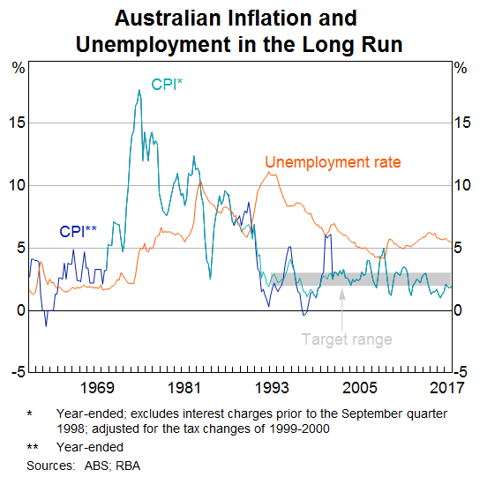

SECTION IV
Total marks (20)
Attempt either
Question 27 or Question 28
Allow about 35 minutes for this section

In your answer you will be assessed on how well you:
■ demonstrate knowledge and understanding relevant to the question
■ apply relevant economic information, terms, concepts, relationships and theory
■ present a sustained, logical and cohesive response

Question 27 (20 marks)

Discuss the causes of Australia’s persistent Current Account Deficit and its effects on the Australian economy.

OR

Question 28 (20 marks)

Discuss the impact of fluctuations in Australia’s exchange rate on the economic performance of the Australian economy.

Student Number: ______________________________

Economics Trial Examination: Section I Answer Sheet

Complete your answers to Questions 1-20 in the table provided below.
Select your answer by placing an X over the correct option.

1 | A | B | C | D
2 | A | B | C | D
3 | A | B | C | D
4 | A | B | C | D
5 | A | B | C | D
6 | A | B | C | D
7 | A | B | C | D
8 | A | B | C | D
9 | A | B | C | D
10 | A | B | C | D
11 | A | B | C | D
12 | A | B | C | D
13 | A | B | C | D
14 | A | B | C | D
15 | A | B | C | D
16 | A | B | C | D
17 | A | B | C | D
18 | A | B | C | D
19 | A | B | C | D
20 | A | B | C | D

- B C D

- A B C D

- A B C D

- A B C D

- A B C D

- A B C D

- A B C D

- A B C D

- A B C D

- A B C D

- A B C D

- A B C D

- A B C D

- A B C D

- A B C D

- A B C D

- A B C D

- A B C D

- …

- ..

- ..

- ..

- ..

- ..

- ..

- ..

- ..

- ..

- ..

- ..

- ..

- ..

- ..

- ..

- ..

- ..

- ..

